Linda M Becken Memorial Preschool Scholarship Trinity Academy
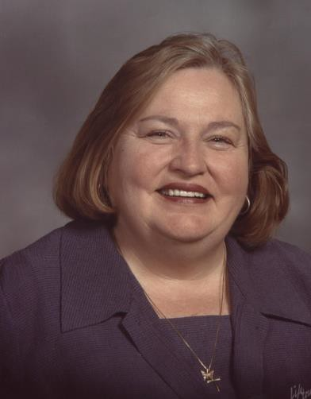

Trinity Academy is dedicated to developing each child’s spiritual and academic gifts and talents. It is a place where childhood is valued and children are nurtured. Trinity academy is a place where parents are invited to participate in the education of their child at all grade levels.
Linda M Becken is the founder of what is now called Trinity Academy. In 1973, she started with child care and over the years progressively added the preschool and elementary programs. She had a passion for children, childhood education, and community involvement. Linda had a generous spirit which reached beyond the classroom.

Scholarship Goals:

- To provide children in our community who are otherwise unable to attend due to financial constraints with the opportunity to experience an exceptional preschool.
- To further our founding mission of providing academic excellence and developing leaders who love a God, love others and serve the world.

Scholarship Recipient Responsibilities:

Scholarship families are asked to embrace the Trinity Academy mission statement and to show active participation in the Trinity community. The partnership between the families and Trinity Academy supports each child’s development and allows the children to reach their full potential. There are many opportunities available.

Scholarship Application Process:

Scholarship Applications are available in the Trinity Academy Office or on-line. Applications should be submitted to the Trinity Academy Principal. The scholarship committee, selected by the Trinity Academy Advisory Board, will then meet to select the scholarship recipients. The family selected will be contacted by the Committee shortly thereafter.

Applications for the 10-month school year September 2018 – June 2019 are due July 30st, 2018. Short term applications can be submitted at any time. Recipients are welcome to reapply the following year.
- Scholarship applications must be complete the application in its entirety.
- The Scholarship Committee will review the submitted application information and determine scholarship awards. Award for the 2018-2019 year will be announced by August 27th, 2018.
- All information received during the application process will be used strictly for determining scholarship eligibility.
- Scholarship may be awarded for enrollment into short or long term Preschool sessions. If recipients have enrolled their child in sessions more than the scholarship award covers, they will be expected to cover those costs independently.

Scholarship Selection Criteria:

- Financial need is a prerequisite for scholarship eligibility.
- Applicants must support and believe in the mission and vision of Trinity Academy and actively participate in the Trinity community.
- Applicants must have some community involvement.

Date:
Linda M Becken Memorial Scholarship Application

Name of Child: Date of Birth:

Family Address:

Telephone #’s:

E-Mail:

Does the Child Currently Attend Preschool? If Yes, Where?

Parent/Guardian 1: Name:
Address (If different from family address): Name & Address of Employer (if applicable): Position:

Parent / Guardian 2: Name:
Address (If different from family address): Name & Address of Employer (if applicable): Position:

Additional Parents/Guardians: Name:
Address (If different from family address): Name & Address of Employer (if applicable): Position:

Estimated Annual Family Income (Circle one):

< $35,000 $35,000 – $45,000 $45,001 - $50,000 $50,001 – $61,000

$61,001 - $76,000 $76,001 – $86,000 $86,001 - $96,000

List all children currently living at home:

Name: Age: Present School: Annual Costs:

Please describe any preschool / social experience your child has had:

How would your child benefit from attending Trinity Preschool?

Why do you choose Trinity Preschool instead of another preschool?

Briefly, tell us about your child:

Are you currently involved within the Trinity or Hudson Community? If so, please describe.

Do you have any special circumstances to consider for scholarship eligibility?

Linda M. Becken’s core belief emphasized the importance of stewardship and connection to ones community. How will your family help enrich, sustain and fulfill this belief?

Your scholarship application will be reviewed upon receipt by the Scholarship Committee. Please fill out your application completely.
Return completed applications to: Alison Johnson, Principal
Trinity Academy Preschool 1205 Sixth Street
Hudson, WI 54016

Scholarships are awarded on a short-term basis for the full school year. Final decisions are at the discretion of the Scholarship Committee.
Scholarship applications are confidential, and will be kept on file for one year.
Notice of nondiscriminatory policy regarding student admission:
Trinity Academy does not discriminate on the basis of race, color, nationality, or ethnic origin in the administration of its educational policies, admission policies, scholarship programs, or other school-administered programs.

